**Final Project Report**

**By: Ali Abdirahman Abdilahi**

1. **Introduction:**

My programming project in started in September 2020. As I was trying to figure out what to make for my project, one day as I was doing my Discrete mathematics homework and the home-work was redundant; that is when it hit me, that I should make a program that help students like me with their assignments and that is when I started working on my “Advance” calculator project. My project is to make the traditional calculator and more like solve equations.

1. **Project Specifications:**

**Project Purpose:**

The purpose of this program is to assist college students and high school students with their assignments and make it faster and easier to get through problems and learn more.

**Project Audience:**

My target project audience are students like myself, ideally in high-school or university.

**Project Aim:**

My primary goal when making this project is to create a easy to use, aesthetically pleasing and functional program. I aim to provide the users as many different mathematical functions and calculators, so that the users of my program can use it solve as many problems as possible.

**Project requirements:**

* Entry forms for the user to enter the problem
* A way of displaying the solutions
* A way to chose the type of calculator you want to use
* A button that allows the user to get the solutions of the problem i.e. an equal button

1. **Solution Design:**

**Overview:**

The general design of my programming project is to create different calculator for different functions and depending on which ever calculator the user wants to use to solve the problem that they want to solve. At the beginning of my program the to type down the type of calculator they are planning on using to solve their particular problem.

1. **Scientific Calculator:** 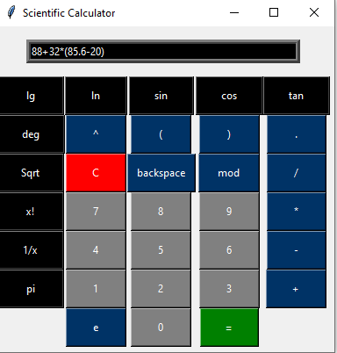

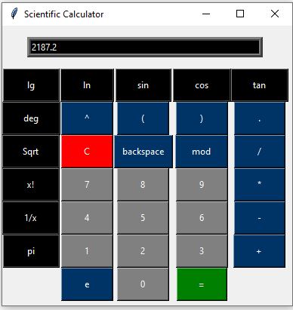

The scientific calculator that I created for my project is like the normal scientific calculator, where the user presses the buttons to input their problem and they press the equal button to get the solution of problem.

1. **Quadratic equation calculator:** 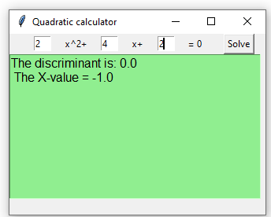

In the quadratic equation calculator the user enters the value for a, b, and c. After hitting the solve button the user gets the discriminant value and the corresponding x-value.

1. **2x2 Matrix Calculator:**

The user of my program can choose the operation that they want to perform on the 2 by 2 matrix whether it is addition, subtraction, multiplication, division, product, inverse or finding the discriminant. Below are some screenshots of my program working.

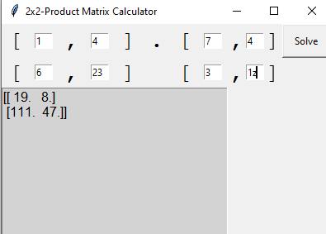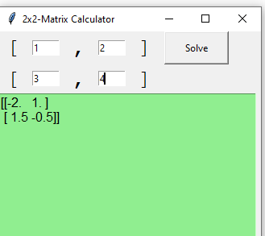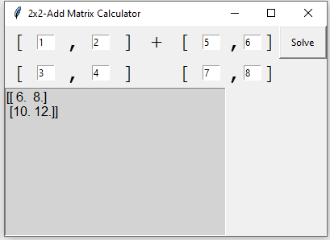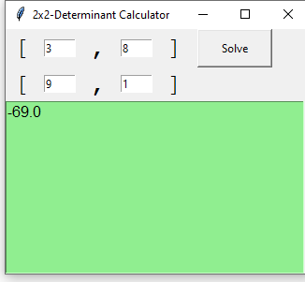

1. **3x3 Matrix Calculator:**

Very much similar to the 2 by matrix calculator, the user can choose the operation that they want to perform on the 3x3 matrix whether it is addition, subtraction, multiplication, division, product or finding the discriminant. Below are some screenshots of my program working.

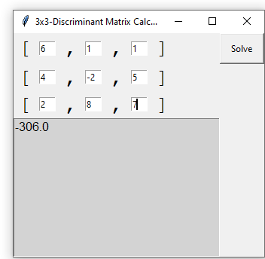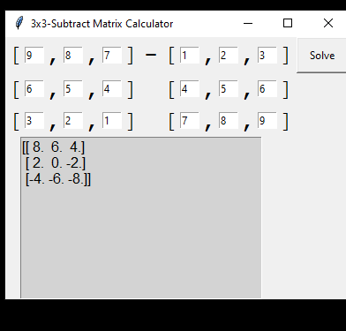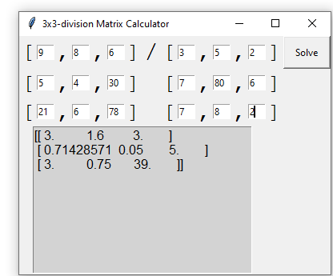

**Conclusion:**

Above is what my programming is about, who it is for and what purpose I created it for and my program in use. This project was my first project and it was more challenging than I anticipated it to be, but I learned a lot in the process of making this project.